TITLE OF MY PROJECT IN UPPERCASE

(PBCST304 -OBJECT ORIENTED PROGRAMMING)

Project Report

STUDENT NAME - University REGNO STUDENT NAME - UNIV REGNO STUDENT NAME - UNIV REGNO STUDENT NAME - UNIV REGNO


DEPARTMENT OF ARTIFICIAL INTELLIGENCE AND MACHINE LEARNING

OCTOBER 2025

`

Marian Engineering College
Menamkulam, Thiruvananthapuram

DEPARTMENT OF ARTIFICIAL INTELLIGENCE AND MACHINE LEARNING

CERTIFICATE
This is to certify that this project work report entitled ‘TITLE OF MY PROJECT IN UPPERCASE’ submitted by STUDENT NAME (STC22CS0XX), STUDENT NAME (STC22CS0XX), STUDENT NAME (STC22CS0XX), and STUDENT NAME
(STC22CS0XX), of Third Semester, B.Tech in Artificial Intelligence and Machine Learning has been successfully carried out under our supervision and guidance in partial fulfillment of the requirements of the project for the subject PBCST304 – Object Oriented Programming, prescribed by APJ Abdul Kalam Technological University, Kerala. It is further certified that this work is a bona fide record of the project carried out by the above students during the academic year 2025–2026.

Renetha J B
Assistant Professor
Department Of Computer Science & Engineering
Marian Engineering College

DECLARATION

We hereby declare that the microproject report TITLE OF PROJECT submitted for the partial fulfilment of the requirements of the Third Semester Project for the subject PBCST304 – Object Oriented Programming, prescribed by APJ Abdul Kalam Technological University, Kerala is a bona fide work done by us under the supervision of Ms. Renetha J B, Assistant Professor, CSE.
The submission represents our ideas in our own words and where ideas or words of others have not been included. We have adequately and accurately cited and referred the original sources.
We also declare that we have adhered to the ethics and integrity and have not misinterpreted or fabricated any data or idea or fact or source in our submission .We understand that any violation of the above will be a case for disciplinary action by the institution and/or the University and can also evoke penal actions from the sources which have thus not been properly cited or from whom proper permission has not been obtained. This report has not previously formed the basis for the award of any degree, diploma or similar title of any other University.

Place: Thiruvananthapuram Date:
STUDENT NAME STUDENT NAME STUDENT NAME STUDENT NAME

Wriet the abstract here.

CONTENTS

Abstract i
List of Figures v

List of Tables vi

List of Abbreviations vii

Introduction 1
  - Background . . . . . . . . . . . . . . . . . . . . . . . . . . . . . . . . . . . . . . . . . . . . . . . . 2
  - Relevance . . . . . . . . . . . . . . . . . . . . . . . . . . . . . . . . . . . . . . . . . . . . . . . . . . 3

Aim and Objectives 5

Requirement Specification 16
  - Software requirements . . . . . . . . . . . . . . . . . . . . . . . . . . . . . . ……... . . 16
  - Hardware requirements. . . . . . . . . . . . . . . . . . . . . . . . . . . . . . . ……… 18
4 Design documentation | 31
4.1 Class diagram  4.2 Database design | 32  32
5 System Implementation | 51
6 System Output/Screenshot | 52
7 Source Code Listing | 53
8. Conclusion | 60

  - Survey Workflow [2] . . . . . . . . . . . . . . . . . . . . . . . . . . . .. . . . . . . . . . . . . . . . . . . . 11
  - Database summary for Wound severity classification ….. . . . . . . . . . . . . . . . . . . . 13
  - Interactive work flow of the smart mobile system [4]. . . . . . . . . . . . . . . . . . . . . . . 14
  - General deep learning models used in different tasks [5]. . . . . . . . . . . . . . . . . . . . . 15

  - Unit test : Model testing . . . . . . . . . . . . . . . . . . . . . . . . . . . . . . . . . . . . . . . . . . . 41
5.2 Unit test : API testing . . . . . . . . . . . . . . . . . . . . . . . . . . . . . . . . . . . . . . . . . . . . . 43
5.3 Integration test . . . . . . . . . . . . . . . . . . . . . . . . . . . . . . . . . . . . . . . . . . . . . . . . . . . 45

Abbreviation | Expansion
AAA | American Automobile Association
HAS | High Altitude Simulation
LMTD | Logarithmic Mean Temperature Difference
PDF | Probability Density Function
*** | ***

Chapter 1 INTRODUCTION
Rules and regulations are paramount to all aspects of life and it accommodates both how one wishes to live, and how others should accommodate one’s lifestyle. Proponents have asserted that crime which is a violation against laws of the society, is integral to the human nature and hence the society can never be completely free from it. Modern society is characterized by increasing levels of risk posed by internal and external security threats. Within this context, security driven by technology is increasingly being used by government, corporate bodies and individuals to monitor and reduce risk.
The widely employed Crime Record Management method in the Nigerian Police Force (NPF) is the manual process. This approach entails the use of paper files in the documentation of criminal information by the NPF. A complainant fills in a First Information Report [FIR] form which includes his or her statement concerning the accused. When the accused is brought in, their details are handwritten into case files. Prior to the advent of computers, these files were kept in wooden or metal wardrobes under lock and key. This was susceptible to damage by pest and unfavorable environmental conditions.
In recent years, as a result of the global rise in application of computers in various aspects of life, desktop applications such as Microsoft Excel were adopted, thereby causing the approach to become both manual and slightly computerized in Nigeria. However, this method of record keeping results in inconsistencies, wastage of disk space and poor control and coordination of data. The employment of this method results from reasons such as:
- Inadequate funding
- Corruption and extortion and
- Lack of necessary skills and resources for statistical and information management.
Criminal Records Management System
This system was aimed at the implementation of a Criminal Records Management System. It is a database system in which the police keep the record of criminals who have been arrested, to be arrested, or escaped. This will help the police department in enhanced management of information. The main entities in the whole process include; the petitioner (the person who files a First Incident Report (FIR)), victim, accused or criminal, case, and investigating officer. The CRMS keeps records of the petitioner, victim, accused, FIR, case and investigation officer entities.

Chapter 2
AIM AND OBJECTIVES

The proposed Crime Record Management System enhances the crime recording operations of the Nigerian Police Force. The aim is to store records in a centralized database which holds information about criminals, crime and users of the system. The database is the basis for all actions in the system and can be easily updated and used to aid in all of the system’s processes, that is, all of the required information is stored in one central location and thus is easily accessible. Furthermore, the correctness of the centralized database will allow functions such as crime report generation and statistical analysis of crime data. This is a more effective storage method than a paper-based file system.
In addition to the functions highlighted above, the system performs the basic functions of storage, retrieval and manipulation of crime and criminal data and information.
The Objectives of the proposed system are as follows:
i. Interstation communication in real time
ii. Centralized data handling
iii. Reduced time consumption
iv. Computerized record keeping with manpower
v. Cost reduction
vi. Operational efficiency
Chapter 3

REQUIREMENT SPECIFICATION

3.1 SOFTWARE REQUIREMENTS
- Operating System: Windows (2000, Vista, 7 and 8)
- Graphical User Interface: Java frame form.
- Database: MySQL
- IDE/Workbench: Xamp
- (APACHE SERVER)

3.2 HARDWARE REQUIREMENTS
- Processor: Pentium III – 900 MHz
- 512 MB RAM (minimum main memory space recommended)
- 768 MB RAM (main memory space recommended)
- 560 – 760 MB minimum hard disk space (depending on features installed)
- 4GB Hard disk space (recommended)

Chapter 4

DATABASE DESIGN

Database Testing: A database is a repository of data of various types. As a result of this, many types of integration and implementation errors may occur in large database systems, which influence the system operation negatively. It is therefore of pivotal importance to test the database in order to achieve a database that satisfies the ACID (atomicity, consistency, Isolation, durability) properties of a database management system.
Below are some of the screenshots of some tables in the database of the proposed system.
ADMIN REGISTRATION TABLE
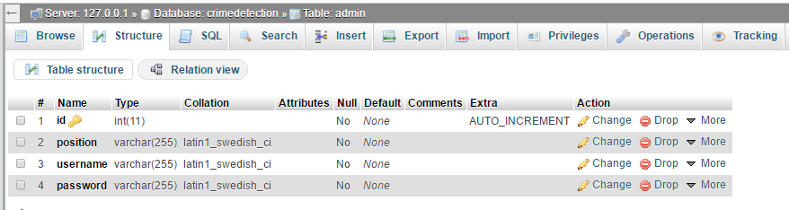
Table 1 shows the ADMIN table which holds information of an administrator. It contains the admin id as the primary key and admin specification such as; position and username and password.
CRIMINAL REGISTRATION TABLE
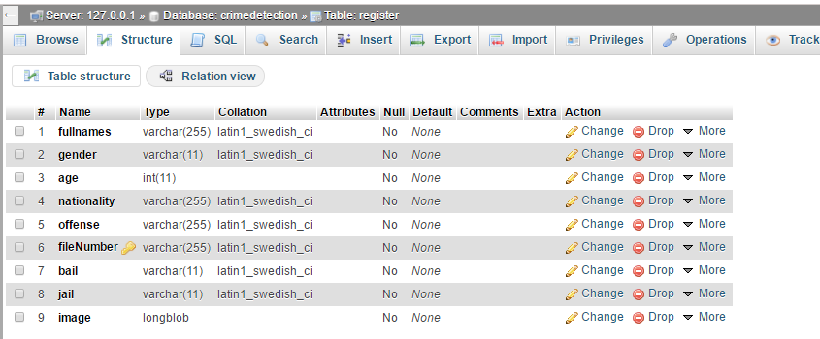
Table 2 shows the crime registration table which holds information on the crime. It contains the crime id as the primary key and crime specification such as; name, offense, file number, full name of offender, probable jail sentence, bail and image of criminal.
Chapter 5

SYSTEM IMPLEMENTATION

Programming language used includes the followings:

- Java
- Structured query language

Chapter 6
SYSTEM OUTPUT/SCREENSHOT
This involves testing the various modules of the system individually, integrating the various components into one, and testing the CRMS as a whole. The CRMS consists of various modules. Some of them are:
i. Login Module: Figure 1 shows the Login page. This is also known as the authentication module. This module is responsible for logging users into the system. This is done by providing a correct and already registered police id and password, without which the user is denied access to the system.
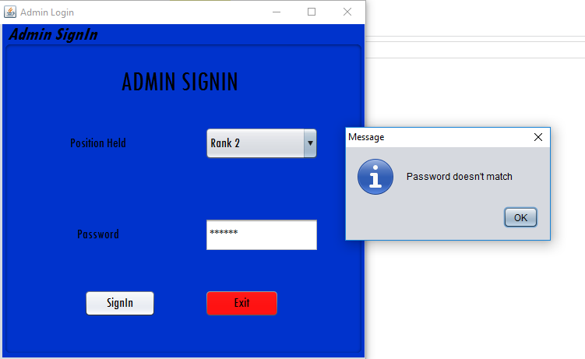

ii. Homepage Module: Figure 2 shows the Homepage module. This module is responsible for redirecting users to perform other activities on the application.
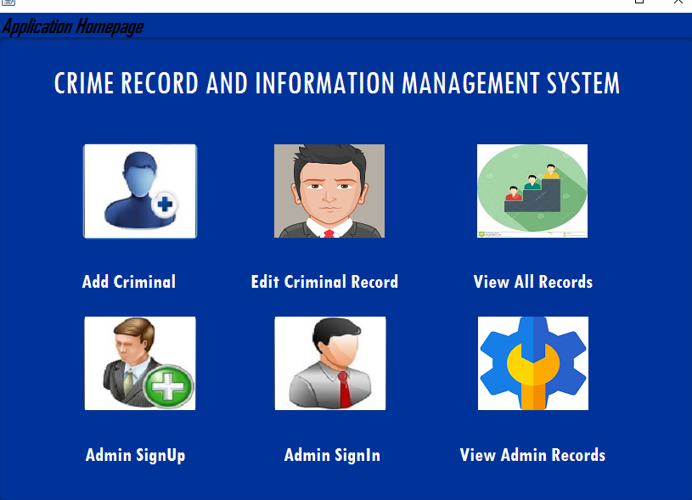
iii. Add Criminal Record Module: Figure 3 shows the criminal record module where specific information about the offender and type of offense committed are entered into a centralized database.
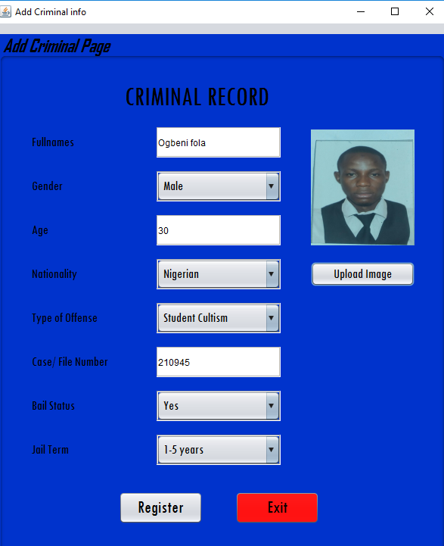

iv. Edit Criminal Record Module: Figure 4 shows the edit module where criminal’s record can be updated and when they are granted bail such criminal record can be deleted off the database and such person is said to be free.
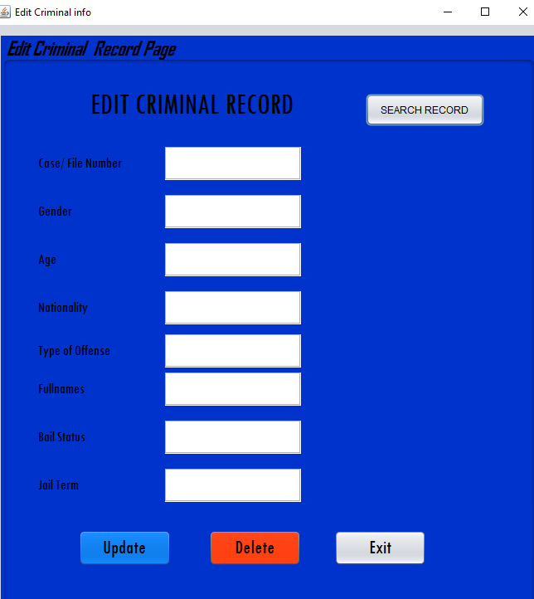
v. Display Offenders Record: This module allows administrators view all records of offenders who have a track record with the agency it contains specific details about the criminal and type of offense committed.
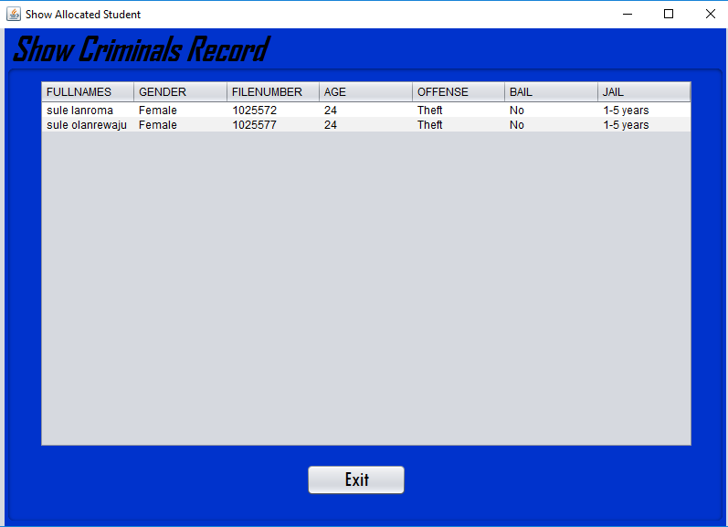
Chapter 7

CODE LISTING
i. Admin Signup
import java.awt.HeadlessException;
import java.sql.Connection;
import java.sql.ResultSet;
import java.sql.SQLException;
import java.sql.Statement;
import javax.swing.JOptionPane;

/**
*
* @author fola
*/
public class HomeSignup extends javax.swing.JFrame {

Connection conn = null;
Statement stmt = null;
ResultSet rs = null;

public HomeSignup() {
super("Create Admin");
initComponents();
conn = dbaseConnx.openConnection();
}

/**
* This method is called from within the constructor to initialize the form.
* WARNING: Do NOT modify this code. The content of this method is always
* regenerated by the Form Editor.
*/
@SuppressWarnings("unchecked")
// <editor-fold defaultstate="collapsed" desc="Generated Code">
private void initComponents() {

jPanel1 = new javax.swing.JPanel();
jLabel1 = new javax.swing.JLabel();
jLabel2 = new javax.swing.JLabel();
Password = new javax.swing.JLabel();
username = new javax.swing.JTextField();
password = new javax.swing.JPasswordField();
Signup = new javax.swing.JButton();
Exit = new javax.swing.JButton();
position = new javax.swing.JComboBox();
jLabel4 = new javax.swing.JLabel();

setDefaultCloseOperation(javax.swing.WindowConstants.EXIT_ON_CLOSE);

jPanel1.setBackground(new java.awt.Color(0, 51, 204));
jPanel1.setBorder(javax.swing.BorderFactory.createTitledBorder(null, "Admin Signup", javax.swing.border.TitledBorder.DEFAULT_JUSTIFICATION, javax.swing.border.TitledBorder.DEFAULT_POSITION, new java.awt.Font("Tw Cen MT Condensed", 3, 24), new java.awt.Color(0, 0, 0))); // NOI18N

jLabel1.setFont(new java.awt.Font("Tw Cen MT Condensed", 0, 36)); // NOI18N
jLabel1.setHorizontalAlignment(javax.swing.SwingConstants.CENTER);
jLabel1.setText("ADMIN SIGNUP");
jLabel1.setCursor(new java.awt.Cursor(java.awt.Cursor.HAND_CURSOR));

jLabel2.setFont(new java.awt.Font("Tw Cen MT Condensed", 0, 18)); // NOI18N
jLabel2.setHorizontalAlignment(javax.swing.SwingConstants.CENTER);
jLabel2.setText("Username");

Password.setFont(new java.awt.Font("Tw Cen MT Condensed", 0, 18)); // NOI18N
Password.setHorizontalAlignment(javax.swing.SwingConstants.CENTER);
Password.setText("Password");

username.setFont(new java.awt.Font("Tw Cen MT Condensed", 0, 18)); // NOI18N
username.addActionListener(new java.awt.event.ActionListener() {
public void actionPerformed(java.awt.event.ActionEvent evt) {
usernameActionPerformed(evt);
}
});

password.setFont(new java.awt.Font("Tw Cen MT Condensed", 0, 18)); // NOI18N
password.addActionListener(new java.awt.event.ActionListener() {
public void actionPerformed(java.awt.event.ActionEvent evt) {
passwordActionPerformed(evt);
}
});

Signup.setFont(new java.awt.Font("Tw Cen MT Condensed", 0, 18)); // NOI18N
Signup.setText("Signup");
Signup.setCursor(new java.awt.Cursor(java.awt.Cursor.HAND_CURSOR));
Signup.addActionListener(new java.awt.event.ActionListener() {
public void actionPerformed(java.awt.event.ActionEvent evt) {
SignupActionPerformed(evt);
}
});

Exit.setBackground(new java.awt.Color(255, 0, 0));
Exit.setFont(new java.awt.Font("Tw Cen MT Condensed", 0, 18)); // NOI18N
Exit.setText("Exit");
Exit.setToolTipText("");
Exit.setCursor(new java.awt.Cursor(java.awt.Cursor.HAND_CURSOR));
Exit.addActionListener(new java.awt.event.ActionListener() {
public void actionPerformed(java.awt.event.ActionEvent evt) {
ExitActionPerformed(evt);
}
});

position.setFont(new java.awt.Font("Tw Cen MT Condensed", 0, 18)); // NOI18N
position.setModel(new javax.swing.DefaultComboBoxModel(new String[] { "Rank 1", "Rank 2", "Rank 3", " " }));

jLabel4.setFont(new java.awt.Font("Tw Cen MT Condensed", 0, 18)); // NOI18N
jLabel4.setHorizontalAlignment(javax.swing.SwingConstants.CENTER);
jLabel4.setText("Position Held");

javax.swing.GroupLayout jPanel1Layout = new javax.swing.GroupLayout(jPanel1);
jPanel1.setLayout(jPanel1Layout);
jPanel1Layout.setHorizontalGroup(
jPanel1Layout.createParallelGroup(javax.swing.GroupLayout.Alignment.LEADING)
.addGroup(jPanel1Layout.createSequentialGroup()
.addGroup(jPanel1Layout.createParallelGroup(javax.swing.GroupLayout.Alignment.LEADING)
.addGroup(jPanel1Layout.createSequentialGroup()
.addGap(35, 35, 35)
.addGroup(jPanel1Layout.createParallelGroup(javax.swing.GroupLayout.Alignment.LEADING)
.addGroup(jPanel1Layout.createSequentialGroup()
.addGroup(jPanel1Layout.createParallelGroup(javax.swing.GroupLayout.Alignment.LEADING)
.addComponent(jLabel4, javax.swing.GroupLayout.PREFERRED_SIZE, 148, javax.swing.GroupLayout.PREFERRED_SIZE)
.addComponent(jLabel2, javax.swing.GroupLayout.DEFAULT_SIZE, javax.swing.GroupLayout.DEFAULT_SIZE, Short.MAX_VALUE))
.addGap(31, 31, 31)
.addGroup(jPanel1Layout.createParallelGroup(javax.swing.GroupLayout.Alignment.LEADING)
.addComponent(username, javax.swing.GroupLayout.PREFERRED_SIZE, 146, javax.swing.GroupLayout.PREFERRED_SIZE)
.addComponent(position, javax.swing.GroupLayout.PREFERRED_SIZE, 146, javax.swing.GroupLayout.PREFERRED_SIZE)))
.addComponent(jLabel1, javax.swing.GroupLayout.PREFERRED_SIZE, 357, javax.swing.GroupLayout.PREFERRED_SIZE)))
.addGroup(jPanel1Layout.createSequentialGroup()
.addGap(27, 27, 27)
.addGroup(jPanel1Layout.createParallelGroup(javax.swing.GroupLayout.Alignment.TRAILING)
.addComponent(Password, javax.swing.GroupLayout.PREFERRED_SIZE, 134, javax.swing.GroupLayout.PREFERRED_SIZE)
.addComponent(Signup, javax.swing.GroupLayout.PREFERRED_SIZE, 92, javax.swing.GroupLayout.PREFERRED_SIZE))
.addGroup(jPanel1Layout.createParallelGroup(javax.swing.GroupLayout.Alignment.LEADING)
.addGroup(jPanel1Layout.createSequentialGroup()
.addGap(39, 39, 39)
.addComponent(password, javax.swing.GroupLayout.PREFERRED_SIZE, 146, javax.swing.GroupLayout.PREFERRED_SIZE))
.addGroup(jPanel1Layout.createSequentialGroup()
.addGap(59, 59, 59)
.addComponent(Exit, javax.swing.GroupLayout.PREFERRED_SIZE, 95, javax.swing.GroupLayout.PREFERRED_SIZE)))))
.addContainerGap(45, Short.MAX_VALUE))
);

jPanel1Layout.linkSize(javax.swing.SwingConstants.HORIZONTAL, new java.awt.Component[] {Password, jLabel2, jLabel4});

jPanel1Layout.linkSize(javax.swing.SwingConstants.HORIZONTAL, new java.awt.Component[] {password, position, username});

jPanel1Layout.setVerticalGroup(
jPanel1Layout.createParallelGroup(javax.swing.GroupLayout.Alignment.LEADING)
.addGroup(jPanel1Layout.createSequentialGroup()
.addComponent(jLabel1, javax.swing.GroupLayout.PREFERRED_SIZE, 72, javax.swing.GroupLayout.PREFERRED_SIZE)
.addGroup(jPanel1Layout.createParallelGroup(javax.swing.GroupLayout.Alignment.LEADING)
.addGroup(jPanel1Layout.createSequentialGroup()
.addGap(95, 95, 95)
.addGroup(jPanel1Layout.createParallelGroup(javax.swing.GroupLayout.Alignment.BASELINE)
.addComponent(username, javax.swing.GroupLayout.PREFERRED_SIZE, 40, javax.swing.GroupLayout.PREFERRED_SIZE)
.addComponent(jLabel2, javax.swing.GroupLayout.PREFERRED_SIZE, 40, javax.swing.GroupLayout.PREFERRED_SIZE)))
.addGroup(jPanel1Layout.createSequentialGroup()
.addGap(22, 22, 22)
.addGroup(jPanel1Layout.createParallelGroup(javax.swing.GroupLayout.Alignment.BASELINE)
.addComponent(jLabel4, javax.swing.GroupLayout.PREFERRED_SIZE, 37, javax.swing.GroupLayout.PREFERRED_SIZE)
.addComponent(position, javax.swing.GroupLayout.PREFERRED_SIZE, 42, javax.swing.GroupLayout.PREFERRED_SIZE))))
.addPreferredGap(javax.swing.LayoutStyle.ComponentPlacement.RELATED, 29, Short.MAX_VALUE)
.addGroup(jPanel1Layout.createParallelGroup(javax.swing.GroupLayout.Alignment.BASELINE)
.addComponent(password, javax.swing.GroupLayout.PREFERRED_SIZE, 43, javax.swing.GroupLayout.PREFERRED_SIZE)
.addComponent(Password, javax.swing.GroupLayout.PREFERRED_SIZE, 39, javax.swing.GroupLayout.PREFERRED_SIZE))
.addGap(47, 47, 47)
.addGroup(jPanel1Layout.createParallelGroup(javax.swing.GroupLayout.Alignment.BASELINE)
.addComponent(Signup, javax.swing.GroupLayout.PREFERRED_SIZE, 35, javax.swing.GroupLayout.PREFERRED_SIZE)
.addComponent(Exit, javax.swing.GroupLayout.PREFERRED_SIZE, 35, javax.swing.GroupLayout.PREFERRED_SIZE))
.addGap(38, 38, 38))
);

jPanel1Layout.linkSize(javax.swing.SwingConstants.VERTICAL, new java.awt.Component[] {Password, jLabel2, jLabel4});

jPanel1Layout.linkSize(javax.swing.SwingConstants.VERTICAL, new java.awt.Component[] {password, position, username});

javax.swing.GroupLayout layout = new javax.swing.GroupLayout(getContentPane());
getContentPane().setLayout(layout);
layout.setHorizontalGroup(
layout.createParallelGroup(javax.swing.GroupLayout.Alignment.LEADING)
.addGroup(javax.swing.GroupLayout.Alignment.TRAILING, layout.createSequentialGroup()
.addContainerGap(javax.swing.GroupLayout.DEFAULT_SIZE, Short.MAX_VALUE)
.addComponent(jPanel1, javax.swing.GroupLayout.PREFERRED_SIZE, javax.swing.GroupLayout.DEFAULT_SIZE, javax.swing.GroupLayout.PREFERRED_SIZE)
.addGap(1, 1, 1))
);
layout.setVerticalGroup(
layout.createParallelGroup(javax.swing.GroupLayout.Alignment.LEADING)
.addGroup(layout.createSequentialGroup()
.addComponent(jPanel1, javax.swing.GroupLayout.DEFAULT_SIZE, javax.swing.GroupLayout.DEFAULT_SIZE, Short.MAX_VALUE)
.addContainerGap())
);

pack();
}// </editor-fold>

private void usernameActionPerformed(java.awt.event.ActionEvent evt) {
// TODO add your handling code here:
}

private void passwordActionPerformed(java.awt.event.ActionEvent evt) {
// TODO add your handling code here:
}

private void SignupActionPerformed(java.awt.event.ActionEvent evt) {
// TODO add your handling code here:
try{
stmt = conn.createStatement();
String Position = (String) position.getSelectedItem();
String Username = username.getText();
String Password = password.getText();

if("".equals(Position)){
JOptionPane.showMessageDialog(null, "The admin rank field is required");
}else if("".equals(Username)){
JOptionPane.showMessageDialog(null, "The username field is required");
}else if("".equals(Password)){
JOptionPane.showMessageDialog(null, "The password field is required");
}else{
String sql = "INSERT INTO admin (position , username, password) VALUES ('"+Position+"', '"+Username+"', '"+ Password+"')";
stmt.executeUpdate(sql);
JOptionPane.showMessageDialog(null, "New Admin Created");

setVisible(false);
Homepage object = new Homepage();
object.setVisible(true);
}
}catch (SQLException | HeadlessException e){
JOptionPane.showMessageDialog(null, e);
}
}

private void ExitActionPerformed(java.awt.event.ActionEvent evt) {
// TODO add your handling code here:
System.exit(0);
}

/**
* @param args the command line arguments
*/
public static void main(String args[]) {
/* Set the Nimbus look and feel */
//<editor-fold defaultstate="collapsed" desc=" Look and feel setting code (optional) ">
/* If Nimbus (introduced in Java SE 6) is not available, stay with the default look and feel.
* For details see http://download.oracle.com/javase/tutorial/uiswing/lookandfeel/plaf.html
*/
try {
for (javax.swing.UIManager.LookAndFeelInfo info : javax.swing.UIManager.getInstalledLookAndFeels()) {
if ("Nimbus".equals(info.getName())) {
javax.swing.UIManager.setLookAndFeel(info.getClassName());
break;
}
}
} catch (ClassNotFoundException ex) {
java.util.logging.Logger.getLogger(HomeSignup.class.getName()).log(java.util.logging.Level.SEVERE, null, ex);
} catch (InstantiationException ex) {
java.util.logging.Logger.getLogger(HomeSignup.class.getName()).log(java.util.logging.Level.SEVERE, null, ex);
} catch (IllegalAccessException ex) {
java.util.logging.Logger.getLogger(HomeSignup.class.getName()).log(java.util.logging.Level.SEVERE, null, ex);
} catch (javax.swing.UnsupportedLookAndFeelException ex) {
java.util.logging.Logger.getLogger(HomeSignup.class.getName()).log(java.util.logging.Level.SEVERE, null, ex);
}
//</editor-fold>

/* Create and display the form */
java.awt.EventQueue.invokeLater(new Runnable() {
public void run() {
new HomeSignup().setVisible(true);
}
});
}

// Variables declaration - do not modify
private javax.swing.JButton Exit;
private javax.swing.JLabel Password;
private javax.swing.JButton Signup;
private javax.swing.JLabel jLabel1;
private javax.swing.JLabel jLabel2;
private javax.swing.JLabel jLabel4;
private javax.swing.JPanel jPanel1;
private javax.swing.JPasswordField password;
private javax.swing.JComboBox position;
private javax.swing.JTextField username;
// End of variables declaration
}
ii. Admin sign in

import java.awt.HeadlessException;
import java.sql.Connection;
import java.sql.ResultSet;
import java.sql.SQLException;
import java.sql.Statement;
import javax.swing.JOptionPane;

/*
* To change this license header, choose License Headers in Project Properties.
* To change this template file, choose Tools | Templates
* and open the template in the editor.
*/

/**
*
* @author fola
*/
public class HomeSignIn extends javax.swing.JFrame {

/**
* Creates new form HomeSignIn
*/
Connection conn = null;
Statement stmt = null;
ResultSet rs = null;

public HomeSignIn() {
super("Admin Login");
initComponents();
conn = dbaseConnx.openConnection();
}

/**
* This method is called from within the constructor to initialize the form.
* WARNING: Do NOT modify this code. The content of this method is always
* regenerated by the Form Editor.
*/
@SuppressWarnings("unchecked")
// <editor-fold defaultstate="collapsed" desc="Generated Code">
private void initComponents() {

jPanel1 = new javax.swing.JPanel();
jPanel2 = new javax.swing.JPanel();
jLabel1 = new javax.swing.JLabel();
Password = new javax.swing.JLabel();
password = new javax.swing.JPasswordField();
Signup = new javax.swing.JButton();
Exit = new javax.swing.JButton();
position = new javax.swing.JComboBox();
jLabel4 = new javax.swing.JLabel();

setDefaultCloseOperation(javax.swing.WindowConstants.EXIT_ON_CLOSE);

jPanel2.setBackground(new java.awt.Color(0, 51, 204));
jPanel2.setBorder(javax.swing.BorderFactory.createTitledBorder(null, "Admin SignIn", javax.swing.border.TitledBorder.DEFAULT_JUSTIFICATION, javax.swing.border.TitledBorder.DEFAULT_POSITION, new java.awt.Font("Tw Cen MT Condensed", 3, 24), new java.awt.Color(0, 0, 0))); // NOI18N

jLabel1.setFont(new java.awt.Font("Tw Cen MT Condensed", 0, 36)); // NOI18N
jLabel1.setHorizontalAlignment(javax.swing.SwingConstants.CENTER);
jLabel1.setText("ADMIN SIGNIN");
jLabel1.setCursor(new java.awt.Cursor(java.awt.Cursor.HAND_CURSOR));

Password.setFont(new java.awt.Font("Tw Cen MT Condensed", 0, 18)); // NOI18N
Password.setHorizontalAlignment(javax.swing.SwingConstants.CENTER);
Password.setText("Password");

password.setFont(new java.awt.Font("Tw Cen MT Condensed", 0, 18)); // NOI18N
password.addActionListener(new java.awt.event.ActionListener() {
public void actionPerformed(java.awt.event.ActionEvent evt) {
passwordActionPerformed(evt);
}
});

Signup.setFont(new java.awt.Font("Tw Cen MT Condensed", 0, 18)); // NOI18N
Signup.setText("SignIn");
Signup.setCursor(new java.awt.Cursor(java.awt.Cursor.HAND_CURSOR));
Signup.addActionListener(new java.awt.event.ActionListener() {
public void actionPerformed(java.awt.event.ActionEvent evt) {
SignupActionPerformed(evt);
}
});

Exit.setBackground(new java.awt.Color(255, 0, 0));
Exit.setFont(new java.awt.Font("Tw Cen MT Condensed", 0, 18)); // NOI18N
Exit.setText("Exit");
Exit.setToolTipText("");
Exit.setCursor(new java.awt.Cursor(java.awt.Cursor.HAND_CURSOR));
Exit.addActionListener(new java.awt.event.ActionListener() {
public void actionPerformed(java.awt.event.ActionEvent evt) {
ExitActionPerformed(evt);
}
});

position.setFont(new java.awt.Font("Tw Cen MT Condensed", 0, 18)); // NOI18N
position.setModel(new javax.swing.DefaultComboBoxModel(new String[] { "Rank 1", "Rank 2", "Rank 3", " " }));

jLabel4.setFont(new java.awt.Font("Tw Cen MT Condensed", 0, 18)); // NOI18N
jLabel4.setHorizontalAlignment(javax.swing.SwingConstants.CENTER);
jLabel4.setText("Position Held");

javax.swing.GroupLayout jPanel2Layout = new javax.swing.GroupLayout(jPanel2);
jPanel2.setLayout(jPanel2Layout);
jPanel2Layout.setHorizontalGroup(
jPanel2Layout.createParallelGroup(javax.swing.GroupLayout.Alignment.LEADING)
.addGroup(jPanel2Layout.createSequentialGroup()
.addGap(35, 35, 35)
.addGroup(jPanel2Layout.createParallelGroup(javax.swing.GroupLayout.Alignment.LEADING)
.addComponent(jLabel1, javax.swing.GroupLayout.PREFERRED_SIZE, 357, javax.swing.GroupLayout.PREFERRED_SIZE)
.addGroup(jPanel2Layout.createSequentialGroup()
.addGroup(jPanel2Layout.createParallelGroup(javax.swing.GroupLayout.Alignment.LEADING)
.addGroup(jPanel2Layout.createSequentialGroup()
.addGap(56, 56, 56)
.addComponent(Signup, javax.swing.GroupLayout.PREFERRED_SIZE, 92, javax.swing.GroupLayout.PREFERRED_SIZE))
.addComponent(Password, javax.swing.GroupLayout.Alignment.TRAILING, javax.swing.GroupLayout.PREFERRED_SIZE, 134, javax.swing.GroupLayout.PREFERRED_SIZE)
.addComponent(jLabel4, javax.swing.GroupLayout.PREFERRED_SIZE, 148, javax.swing.GroupLayout.PREFERRED_SIZE))
.addPreferredGap(javax.swing.LayoutStyle.ComponentPlacement.RELATED, javax.swing.GroupLayout.DEFAULT_SIZE, Short.MAX_VALUE)
.addGroup(jPanel2Layout.createParallelGroup(javax.swing.GroupLayout.Alignment.LEADING)
.addComponent(position, javax.swing.GroupLayout.Alignment.TRAILING, javax.swing.GroupLayout.PREFERRED_SIZE, 146, javax.swing.GroupLayout.PREFERRED_SIZE)
.addGroup(javax.swing.GroupLayout.Alignment.TRAILING, jPanel2Layout.createParallelGroup(javax.swing.GroupLayout.Alignment.LEADING)
.addComponent(password, javax.swing.GroupLayout.PREFERRED_SIZE, 146, javax.swing.GroupLayout.PREFERRED_SIZE)
.addComponent(Exit, javax.swing.GroupLayout.PREFERRED_SIZE, 95, javax.swing.GroupLayout.PREFERRED_SIZE)))))
.addContainerGap(45, Short.MAX_VALUE))
);

jPanel2Layout.linkSize(javax.swing.SwingConstants.HORIZONTAL, new java.awt.Component[] {Password, jLabel4});

jPanel2Layout.setVerticalGroup(
jPanel2Layout.createParallelGroup(javax.swing.GroupLayout.Alignment.LEADING)
.addGroup(jPanel2Layout.createSequentialGroup()
.addComponent(jLabel1, javax.swing.GroupLayout.PREFERRED_SIZE, 72, javax.swing.GroupLayout.PREFERRED_SIZE)
.addGap(22, 22, 22)
.addGroup(jPanel2Layout.createParallelGroup(javax.swing.GroupLayout.Alignment.BASELINE)
.addComponent(position, javax.swing.GroupLayout.PREFERRED_SIZE, 42, javax.swing.GroupLayout.PREFERRED_SIZE)
.addComponent(jLabel4, javax.swing.GroupLayout.PREFERRED_SIZE, 37, javax.swing.GroupLayout.PREFERRED_SIZE))
.addPreferredGap(javax.swing.LayoutStyle.ComponentPlacement.RELATED, 75, Short.MAX_VALUE)
.addGroup(jPanel2Layout.createParallelGroup(javax.swing.GroupLayout.Alignment.BASELINE)
.addComponent(password, javax.swing.GroupLayout.PREFERRED_SIZE, 43, javax.swing.GroupLayout.PREFERRED_SIZE)
.addComponent(Password, javax.swing.GroupLayout.PREFERRED_SIZE, 39, javax.swing.GroupLayout.PREFERRED_SIZE))
.addGap(49, 49, 49)
.addGroup(jPanel2Layout.createParallelGroup(javax.swing.GroupLayout.Alignment.BASELINE)
.addComponent(Signup, javax.swing.GroupLayout.PREFERRED_SIZE, 35, javax.swing.GroupLayout.PREFERRED_SIZE)
.addComponent(Exit, javax.swing.GroupLayout.PREFERRED_SIZE, 35, javax.swing.GroupLayout.PREFERRED_SIZE))
.addGap(38, 38, 38))
);

jPanel2Layout.linkSize(javax.swing.SwingConstants.VERTICAL, new java.awt.Component[] {Password, jLabel4});

javax.swing.GroupLayout jPanel1Layout = new javax.swing.GroupLayout(jPanel1);
jPanel1.setLayout(jPanel1Layout);
jPanel1Layout.setHorizontalGroup(
jPanel1Layout.createParallelGroup(javax.swing.GroupLayout.Alignment.LEADING)
.addGroup(javax.swing.GroupLayout.Alignment.TRAILING, jPanel1Layout.createSequentialGroup()
.addContainerGap(javax.swing.GroupLayout.DEFAULT_SIZE, Short.MAX_VALUE)
.addComponent(jPanel2, javax.swing.GroupLayout.PREFERRED_SIZE, javax.swing.GroupLayout.DEFAULT_SIZE, javax.swing.GroupLayout.PREFERRED_SIZE)
.addGap(1, 1, 1))
);
jPanel1Layout.setVerticalGroup(
jPanel1Layout.createParallelGroup(javax.swing.GroupLayout.Alignment.LEADING)
.addGroup(jPanel1Layout.createSequentialGroup()
.addComponent(jPanel2, javax.swing.GroupLayout.DEFAULT_SIZE, javax.swing.GroupLayout.DEFAULT_SIZE, Short.MAX_VALUE)
.addContainerGap())
);

javax.swing.GroupLayout layout = new javax.swing.GroupLayout(getContentPane());
getContentPane().setLayout(layout);
layout.setHorizontalGroup(
layout.createParallelGroup(javax.swing.GroupLayout.Alignment.LEADING)
.addComponent(jPanel1, javax.swing.GroupLayout.DEFAULT_SIZE, javax.swing.GroupLayout.DEFAULT_SIZE, Short.MAX_VALUE)
);
layout.setVerticalGroup(
layout.createParallelGroup(javax.swing.GroupLayout.Alignment.LEADING)
.addComponent(jPanel1, javax.swing.GroupLayout.DEFAULT_SIZE, javax.swing.GroupLayout.DEFAULT_SIZE, Short.MAX_VALUE)
);

pack();
}// </editor-fold>

private void passwordActionPerformed(java.awt.event.ActionEvent evt) {
// TODO add your handling code here:
}

private void SignupActionPerformed(java.awt.event.ActionEvent evt) {
// TODO add your handling code here:
try {
stmt = conn.createStatement();
String Position = (String) position.getSelectedItem();
String Pass = password.getText();

String sql = "SELECT * FROM admin WHERE position = '"+ Position +"' && password = '"+ Pass+"'";
rs = stmt.executeQuery(sql);
if("".equals(Pass) || "".equals(Position)){
JOptionPane.showMessageDialog(null, "Password or Position field is required");
}
else if(rs.next()){

JOptionPane.showMessageDialog(null, "Staff login was successful");
setVisible(false);
Homepage object = new Homepage ();
object.setVisible(true);
}else{
JOptionPane.showMessageDialog(null, "Password doesn't match");
}
}catch (SQLException | HeadlessException e){
JOptionPane.showMessageDialog(null, e);

}
}

private void ExitActionPerformed(java.awt.event.ActionEvent evt) {
// TODO add your handling code here:
System.exit(0);
}

/**
* @param args the command line arguments
*/
public static void main(String args[]) {
/* Set the Nimbus look and feel */
//<editor-fold defaultstate="collapsed" desc=" Look and feel setting code (optional) ">
/* If Nimbus (introduced in Java SE 6) is not available, stay with the default look and feel.
* For details see http://download.oracle.com/javase/tutorial/uiswing/lookandfeel/plaf.html
*/
try {
for (javax.swing.UIManager.LookAndFeelInfo info : javax.swing.UIManager.getInstalledLookAndFeels()) {
if ("Nimbus".equals(info.getName())) {
javax.swing.UIManager.setLookAndFeel(info.getClassName());
break;
}
}
} catch (ClassNotFoundException ex) {
java.util.logging.Logger.getLogger(HomeSignIn.class.getName()).log(java.util.logging.Level.SEVERE, null, ex);
} catch (InstantiationException ex) {
java.util.logging.Logger.getLogger(HomeSignIn.class.getName()).log(java.util.logging.Level.SEVERE, null, ex);
} catch (IllegalAccessException ex) {
java.util.logging.Logger.getLogger(HomeSignIn.class.getName()).log(java.util.logging.Level.SEVERE, null, ex);
} catch (javax.swing.UnsupportedLookAndFeelException ex) {
java.util.logging.Logger.getLogger(HomeSignIn.class.getName()).log(java.util.logging.Level.SEVERE, null, ex);
}
//</editor-fold>

/* Create and display the form */
java.awt.EventQueue.invokeLater(new Runnable() {
public void run() {
new HomeSignIn().setVisible(true);
}
});
}

// Variables declaration - do not modify
private javax.swing.JButton Exit;
private javax.swing.JLabel Password;
private javax.swing.JButton Signup;
private javax.swing.JLabel jLabel1;
private javax.swing.JLabel jLabel4;
private javax.swing.JPanel jPanel1;
private javax.swing.JPanel jPanel2;
private javax.swing.JPasswordField password;
private javax.swing.JComboBox position;
// End of variables declaration
}
iii. Crime Record Homepage
/*
* To change this license header, choose License Headers in Project Properties.
* To change this template file, choose Tools | Templates
* and open the template in the editor.
*/

/**
*
* @author fola
*/
public class Homepage extends javax.swing.JFrame {

public Homepage() {
initComponents();
}

/**
* This method is called from within the constructor to initialize the form.
* WARNING: Do NOT modify this code. The content of this method is always
* regenerated by the Form Editor.
*/
@SuppressWarnings("unchecked")
// <editor-fold defaultstate="collapsed" desc="Generated Code">
private void initComponents() {

jPanel1 = new javax.swing.JPanel();
jLabel1 = new javax.swing.JLabel();
editrecord = new javax.swing.JButton();
showrecords = new javax.swing.JButton();
viewAdminRecords = new javax.swing.JButton();
SignIn = new javax.swing.JButton();
jButton5 = new javax.swing.JButton();
addCriminal = new javax.swing.JButton();
jLabel2 = new javax.swing.JLabel();
jLabel3 = new javax.swing.JLabel();
jLabel4 = new javax.swing.JLabel();
jLabel5 = new javax.swing.JLabel();
jLabel6 = new javax.swing.JLabel();
jLabel7 = new javax.swing.JLabel();

setDefaultCloseOperation(javax.swing.WindowConstants.EXIT_ON_CLOSE);

jPanel1.setBackground(new java.awt.Color(0, 51, 153));
jPanel1.setBorder(javax.swing.BorderFactory.createTitledBorder(null, "Application Homepage", javax.swing.border.TitledBorder.DEFAULT_JUSTIFICATION, javax.swing.border.TitledBorder.DEFAULT_POSITION, new java.awt.Font("Agency FB", 3, 24))); // NOI18N

jLabel1.setFont(new java.awt.Font("Tw Cen MT Condensed", 0, 40)); // NOI18N
jLabel1.setForeground(new java.awt.Color(255, 255, 255));
jLabel1.setHorizontalAlignment(javax.swing.SwingConstants.CENTER);
jLabel1.setText("CRIME RECORD AND INFORMATION MANAGEMENT SYSTEM");
jLabel1.setCursor(new java.awt.Cursor(java.awt.Cursor.HAND_CURSOR));

editrecord.setIcon(new javax.swing.ImageIcon(getClass().getResource("/images/avatar5.png"))); // NOI18N
editrecord.addActionListener(new java.awt.event.ActionListener() {
public void actionPerformed(java.awt.event.ActionEvent evt) {
editrecordActionPerformed(evt);
}
});

showrecords.setIcon(new javax.swing.ImageIcon(getClass().getResource("/images/group.jpg"))); // NOI18N
showrecords.addActionListener(new java.awt.event.ActionListener() {
public void actionPerformed(java.awt.event.ActionEvent evt) {
showrecordsActionPerformed(evt);
}
});

viewAdminRecords.setIcon(new javax.swing.ImageIcon(getClass().getResource("/images/operation.png"))); // NOI18N
viewAdminRecords.addActionListener(new java.awt.event.ActionListener() {
public void actionPerformed(java.awt.event.ActionEvent evt) {
viewAdminRecordsActionPerformed(evt);
}

